

Mantid Framework
Tessella Project Number 5315
Managed Workspace
Detailed Design Document

Tessella Support Services plc
E-mail: info@tessella.com | www.tessella.com
Group Head Office: Abingdon
3 Vineyard Chambers, Abingdon, Oxfordshire, OX14 3PX, UK
Tel: +44 (0)1235 555511
Fax: +44 (0)1235 553301

Document Control
This document is under document control. All members of the distribution list will receive updated copies whenever alterations are made.

Contributors
Person | Role | Company | Contribution
Nick Draper | Author | Tessella
Russell Taylor | Reviewer | Tessella

Document Approval
Person | Role | Company

Distribution
Person | Role | Company
Notes Projects Database 5315 |  | Tessella
Mantid SVN repository |  | Rutherford Appleton Laboratories

Revision History
Issue | Author | Date | Description
V1.R1.M0 | Nick Draper | 18-Jan-2008 | 1st version written
V1.R1.M1 | Nick Draper | 03-Nov-2009 | Empty requirements section removed.

References
Ref. | Document | Date | Details and Version
[ADD] | Business Case | 05-Oct-2007 | V1.R1.M2
[UML] | UML Distilled 2nd Edition by M Fowler | 2000 | UML Distilled 2nd Edition by M Fowler, Addison-Wesley, (Tessella ref: 1861)

Table of Contents
1 Introduction 4
1.1 Purpose of this Document 4
1.2 Scope of this Document 4
1.3 Context of this Issue 4
1.4 Definition of Terms 4
2 Detailed Design 5
2.1 Overview and Context 5
2.2 ManagedWorkspace Design 6
2.3 DataBlock Design 7
2.4 ManagedWorkspace DataFile Format 7
2.5 WorkspaceFactory Alterations 7

Introduction

Purpose of this Document
This document describes the detailed design of the Managed Workspace component of the Mantid Framework.
It is based on the design specified in the Architectural Design Document [ADD]
It will form the basis of the development of this aspect of the framework and act as a guide for maintaining the system.

Scope of this Document
These requirements cover the development of the Managed workspace aspect of the Mantid Framework.

Context of this Issue
This is the first draft of the MW-DDD derived from the ADD and after internal review will be updated and used as a basis for the development of the system.

Definition of Terms

ADD | The Architectural Design Document (this document), the high level design document for the entire system.
URD | The User Requirements Document, records the users’ requirements for the system.
SRD | The Software Requirements Document, specifies the behaviour of the software system.
API | Application Programming Interface, defines the interface through which two programs may interact.

Detailed Design

Overview and Context
The Managed workspace is designed to allow the framework to handle volumes of data that are too large to fit into the available system memory.

Benchmark tests have shown that the exiting Workspace2D implementation that stores its data solely in memory can only cope with a 2D array of 10,000 * 2,584 on a 2GB windows XP PC, which is ¼ of the size of a data file from the MAPS instrument 41476 * 2800.

ManagedWorkspace2D will inherit from Workspace2D and therefore will be able to be used interchangeably. The Managed workspace will use a random access binary file as the primary store of the data, and buffers several segments of the data in memory to allow for reasonable data access speeds.
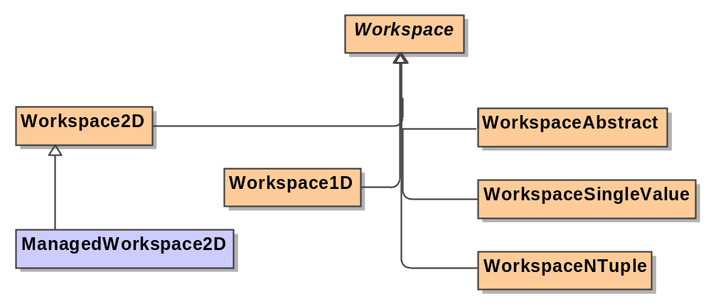

ManagedWorkspace Design
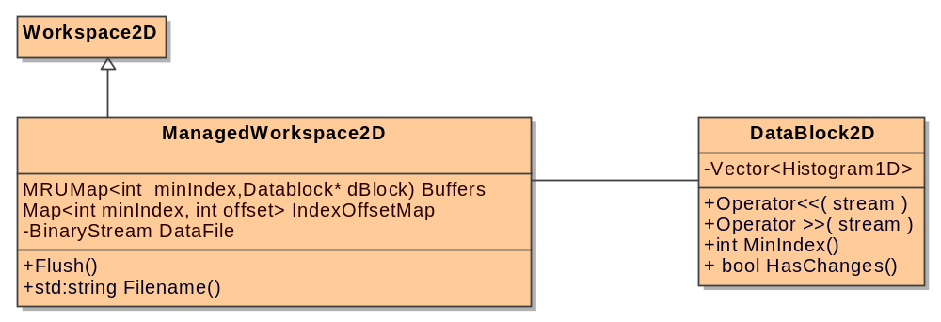

The Managed workspace will contain the following data members:
Name | Type | Contents | Description
Buffers | MRUMap  Built from a boost multi index container. | Several elements of DataBlock2D. These are accessible by the starting index offset that the DataBlock holds. | This is an associative map that hold n elements and drop out the least recently used when the storage limit is reached.  This is used to store n individual buffers of histogram data in memory to provide fast access times.
IndexOffsetMap | Map | Hold key value pairs of the starting index offset that the DataBlock holds and the offset in the binary file to the start of the DataBlock. | A simple ordered key - value map.
DataFile | BinaryStream | A stream to the binary file that holds the data within the ManagedWorkspace.

When a Managed WorkSpace is created it will.
- Calculate the memory required for a single Histogram1D object with the required number of X elements.
- Calculate the number of Histograms that will fit into the ManagedWorkspace.DataBlockSize property of the properties file (using a default of 1MB).
- Generate a DataFile with sufficient datablocks for the required number of detectors.

When a value is requested by index it will:
- Find the closest starting index offset by a binary search of the ordered index lookup table.
- Use the starting index offset to check if the required datablock is in the buffers collection.
  - If not present then load the Datablock from the datafile.
- Add the DataBlock to the Buffers collection.
  - If a datablock is dropped from the buffers collection and is HasChanges. Then its data must be written to the datafile.
- Lookup the value in the datablock.

DataBlock Design
In many ways this class is similar to a Workspace2D, but without the sample, instrument and history data, but with the additional ability to save and load itself to a binary file. The datablock2D will support all of the Iteration required functions detailed in the workspace class in order to allow the workspace iterators to function on this class.

The Managed workspace will contain the following data members:
Name | Type | Contents | Description
Data | Vector<Histogram1D>. | A vector of Histogram1D elements. | The container of the data read from the datafile..
minIndex | int |  | The minimum index of the workspace data that this Datablock contains.
hasChanges | bool |  | A “dirty” flag that is set if any of the elements of Data are accessed. Through non const accessors.

The class will include the operator overloads for the stream operators << and >> to allow serialization to a binary stream format.

ManagedWorkspace DataFile Format
The eventual file format that supports the ManagedWorkspace will comprise of two files. One, a fixed length binary format that will hold the data for the histograms, and another extensible file format that will hold the instrument, sample and history data. For now we will only implement the fixed binary format file and the rest of the data will be held in memory like other non managed workspaces.

The Binary format will be as follows

Header
Int Number of Detectors.
Int Blocksize (number of index values in a block).
Body
Histogram1D objects serialized in index order.

WorkspaceFactory Alterations
The workspace Factory will be altered to provide ManagedWorkspace2D implementations when asked to provide a Workspace2D if the parent workspace provided has an index over n. the value of n will be read from the property ManagedWorkspace.MinIndexSize.

